Back pain can be stressful and scary. It can keep us from our jobs and from time with family and friends. It may also make people afraid that something is seriously wrong. It is very common and nearly everyone will experience lower back pain at some point.
(Please see bottom of page for advice about when to seek emergency assistance.)

The good news
Did you know that 95% of back pain improves a lot over the first couple of weeks? It may take up to two months to feel completely better. Research shows that strong pain does not equal bad injury and it is likely that YOU can manage this with some support.

Where can you get help?
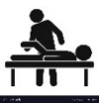
You have options! Reaching out to one of the following when you notice pain will help get you feeling better faster.
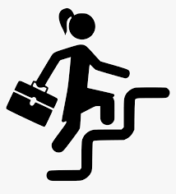
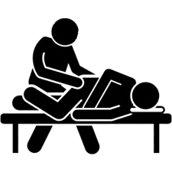
Doctor/Clinic
Nurse line
Send a message
Video visit
Appointment

Insert customized information for your organization

Physical Therapist
Appointment

Insert customized information for your organization

Insurance Plan
24-hour nurse line

Insert customized information for your organization

Employer
Program for back pain

Insert customized information for your organization

Chiropractor
Appointment

Insert customized information for your organization

What can help?
- Stay active (bed rest is not recommended)  - Gentle stretches  - Ice or heat (or alternate them) | - Short term, over the counter pain relievers  - Good sleep  - Reduce stress | - Good posture while sitting,  lifting and sleeping  - Gentle massage  - Supportive shoes (avoid heels) | - Acupuncture  - Yoga  - Tai Chi
Check back with your care team after 2 weeks, or sooner if you have questions or concerns. Keep them in the loop!

What likely won’t help?
- Prolonged rest
- Imaging before 6 weeks (for example: x-rays, CT scans or MRIs)
Ask your care team if this is necessary since the cause of back pain cannot usually be seen on imaging.
- Opioid medication

When to seek emergency assistance:
- You experience weakness in your legs | - You develop a fever
- You have difficulty controlling your bladder or bowels | - You are unsteady on your feet

